Advanced Engineering Mathematics, by Erwin Kreyszig 10th. Ed.

**Problem Set 6.4**

No. 1

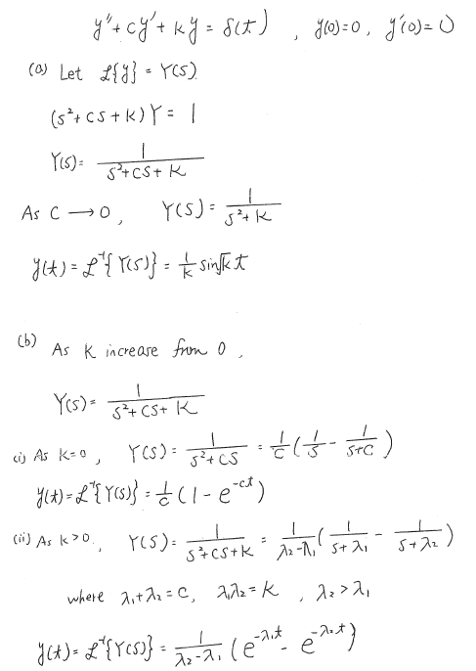



No. 2



No. 3



Make Laplace transformation on both sides of the equation

 are then inserted

 

ℒ－1

另解



ℒ－1

 





No. 4



Make Laplace transformation on both sides of the equation

 are then inserted

 

ℒ－1

另解



ℒ－1

 

 

No. 5



Make Laplace transformation on both sides of the equation

 are then inserted

 

ℒ－1





另解



ℒ－1

 

 

 

No. 6



are then inserted







ℒ－1

另解



ℒ－1

 

 

No. 7



Make Laplace transformation on both sides of the equation



are then inserted



 







ℒ－1







No. 8



  代入

  







ℒ－1

No. 9



 代入













ℒ－1



No. 10







另解

(i)  

(ii)  

(iii) 









No. 11





 are then inserted











ℒ－1

 

No. 12



 代入





ℒ－1



No.13

(a)Set the denominator, then



 

(b) further fraction

Set the denominator,

then



Set 

Then 





No. 14

(a)Prove that ℒ

ℒ

Set  or , 

ℒ

ℒℒ 

ℒ=; ℒ

(b) ℒ

 

=

(c) ℒ

 

=



(d) ℒ







No.15

 minus the function in 14(d)

ℒℒ

